Provider Profile Test Case:
Test Case 20191001 – Diagnostic Tool UI Test
Purpose:
Tester Name: Michelle-Elizabeth Valle  Date(s) of Test: 10/01/2019  Tested on (test environment/platform): Functional test on IP 10.194.52.203 using Chrome Web Browser | Prerequisites for this test: ability to VPN in using Big-IP Edge Client
Software Versions: {name of application your testing, and version}
Browser(s): Chrome
 | Required Configuration: Need to vpn in before testing on IP 10.194.52.203
NOTES and RESULTS: ????

Username: admin@admin
Password: password

Per dev instructions:
Setting up the environment:
- Log in using admin@admin, password credentials
- Create a diagnostic with a good amount of themes and questions
  - You can export a diagnostic from https://strategydiagnostic.boozallencsn.com as to not start from scratch. IT modernization is the most complete diagnostic so far.
  - Edit the diagnostic and review over the diagnostic
  - Add as many questions/answers/themes as you want. There is a duplicate button for themes/questions to make life easier
- Make your diagnostic a “default diagnostic” by clicking the checkbox in the Show For All Users column
- Create additional accounts with credentials you can remember/write down
- Using each account, go ahead and take the diagnostic (it will show up on dashboard) and then generate a report and take a screenshot of the radar chart which will show you the theme scores
- Log out of each account and close any related site windows that are open
- Check the diagnostics to the analytics page when done taking diagnostics

Analytics Page (Click the graph icon on actions column in the dashboard)
- Theme Average Graph
  - The graph correctly displays the mean of the collection of each user’s total score on a theme
  - The error bars correspond with the min and max scores in the collection (allow for possible 1 off errors due to rounding)
  - Document what happens when there are theme titles that are really long
  - Graph remains centered regardless of window resizing/zoom in/zoom out
  - If a theme has no questions, the average score should be 0
- Question level Graphs
  - Each graph should correctly represent the aggregate counts of each answer option
    - If no one answers a question, every count for an answer is 0
  - Hovering over an answer option on the legend grays out all the other answer options.
    - On the graph
    - On the legend
  - Answers that are too long will have an ellipsis to cut them off
  - Question titles that are too long will also be cut off
  - Question Bubbles look good in the case of more than 10 questions in a theme

TEST SCRIPT STEPS/RESULTS
STEP | TEST STEP/INPUT | EXPECTED RESULTS | ACTUAL RESULTS | PASS/FAIL
 | Connect to Big-IP Edge Client | Connected | Connected | PASS
 | Open browser and type in 10.194.52.203 | User navigates to the Diagnostic Tool test environment log in page | 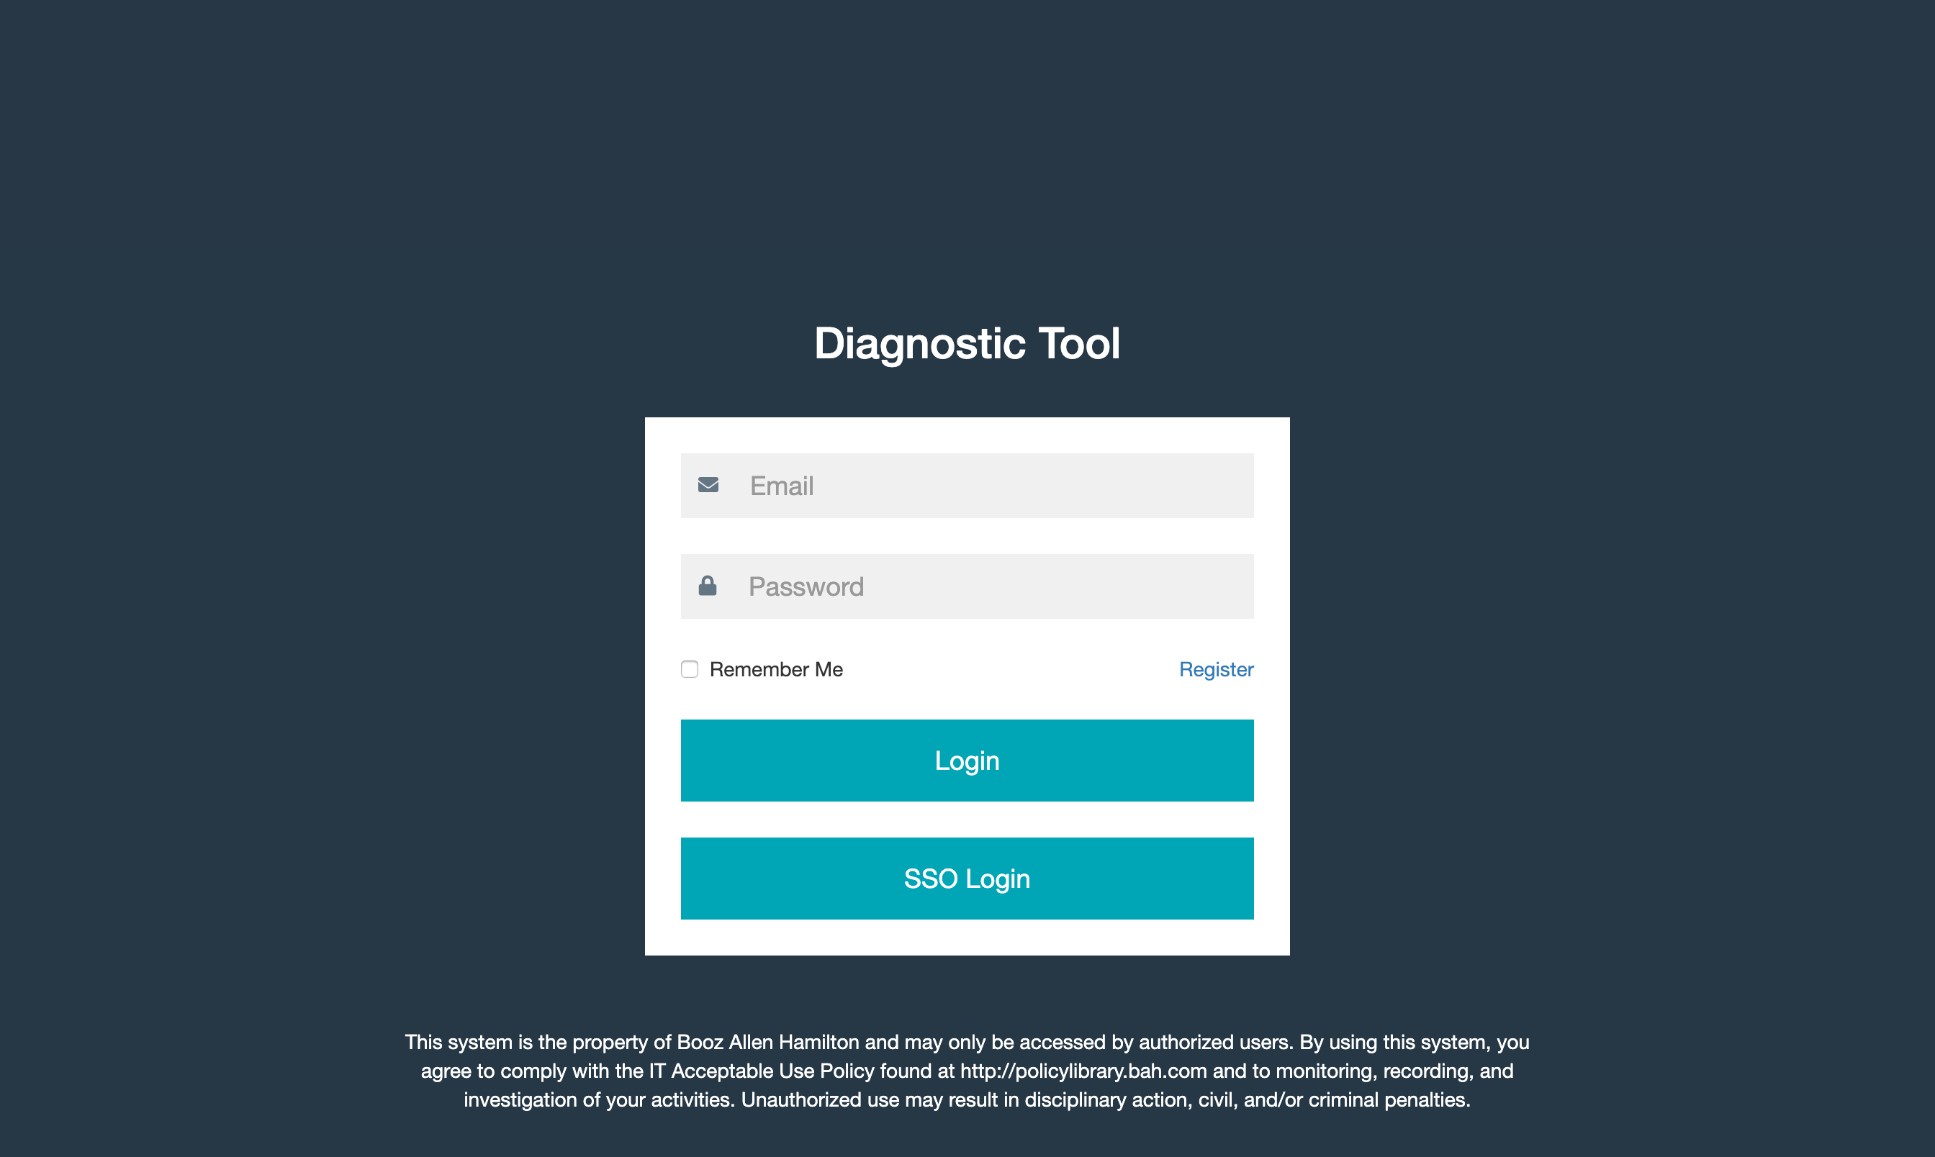 | PASS
 | Enter username and password and click enter | User navigates to the Diagnostic Tool landing page | 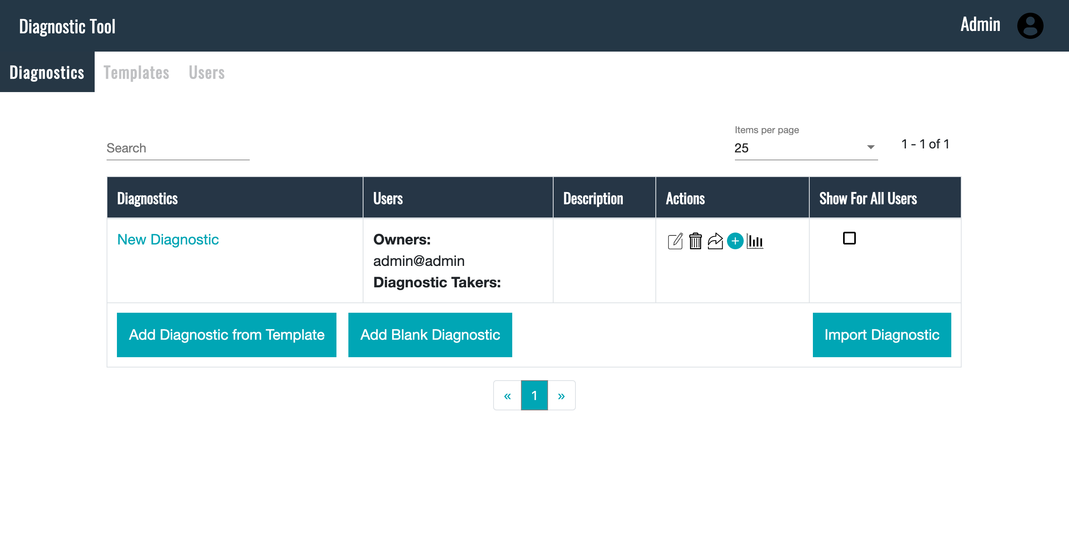 | PASS
 | On landing page, click on “Import Diagnostic” button | User selects a previously saved diagnostic and loads it to the tool.

